* **Experiment 29: motor driver chip L293D**

Contains two H bridge driver circuit, can be used to drive two DC motor

* + speed control
  + Arduino analog output pin

- The resulting PWM signal is connected to the enable pin of the L293D.

directional control

Digital output pin using Arduino

* + The resulting digital signal is connected to the A L293D, B two direction pins
  + Just turn: A is high, B is low
  + Inversion: A is low, B is high

Brake: B, A at the same time as high or low

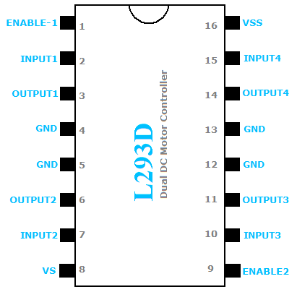

**motor**

**Enable pin**

**directionA**

**directionB**

**Motor power**

**Arduino 5V**

**电机电源和**

**Arduino**

**需要共地!**

code：

